# **Anson California King Sunderland Upholstered Bed**

**Description $1300**

Style Number: 927-327R

Anson was inspired by the timeless lines of our favorite French periods. Notable architectural shapes like columns and coved mouldings make the styling easy to incorporate into classic and transitional spaces. These forms have been softened to allow the personality of flat cut hickory to take center stage. Its casual vibe makes the resulting design fresh approach on traditional. Added details like subtle bow fronts, walnut inlays, and the move toward a mid or satin sheen finish add refinement.

For additional details select the dimensions tab above.

**Details**

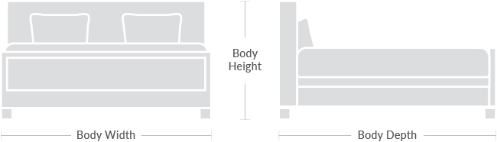**Body Depth:** 93.0  
  
**Body Height:** 66.0  
  
**Body Width:** 79.0